Dash Board:
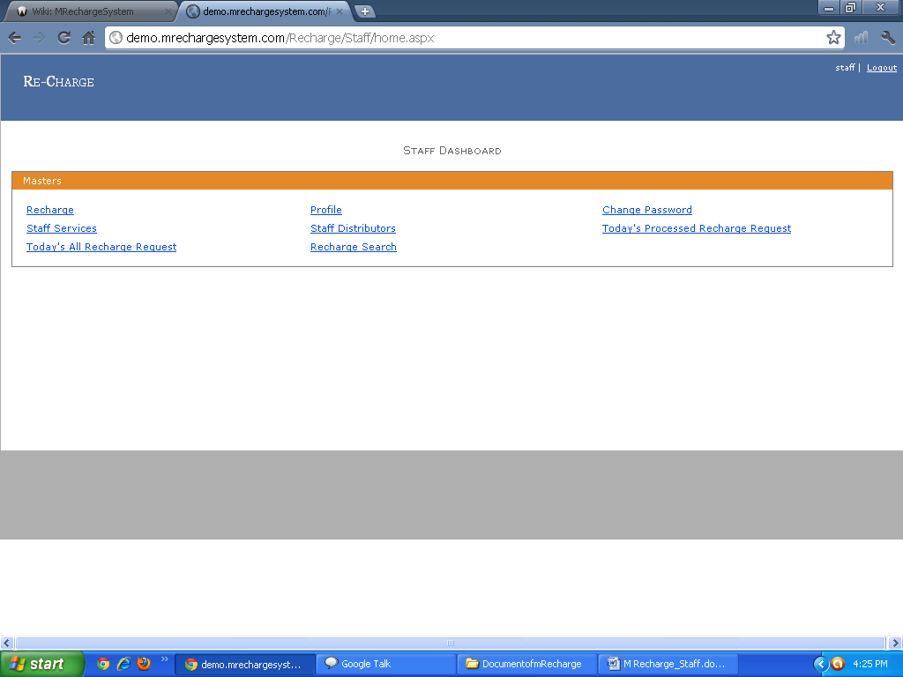
1) Request Recharge: All Recharge Request by Admin, Distributor, Dealer, User can see by Staff Member. and Staff Member Also seen all Details.
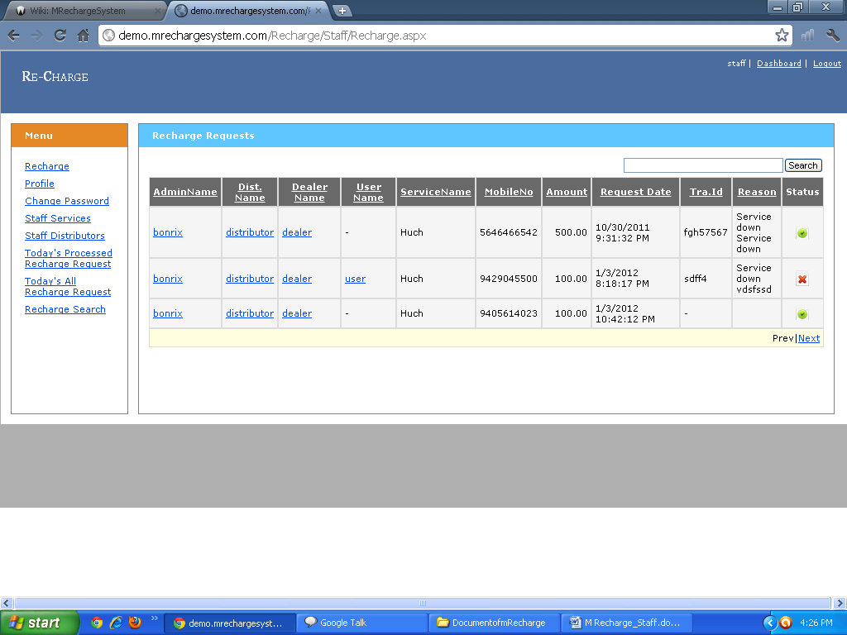

2) Staff Profile: Staff Person can see his Profile and staff Person Also Can Update his Profile.
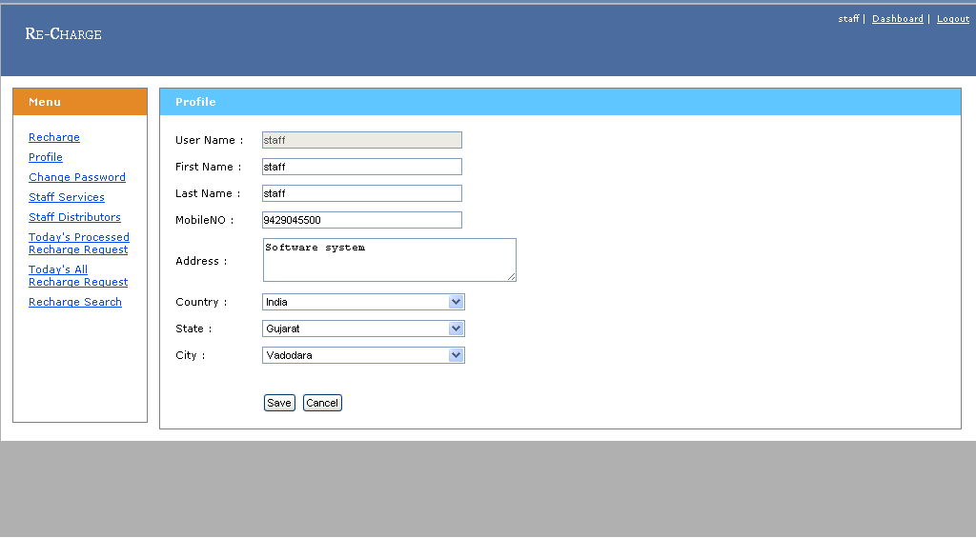
3) Change Password: Staff Person Can Change His Password Also.
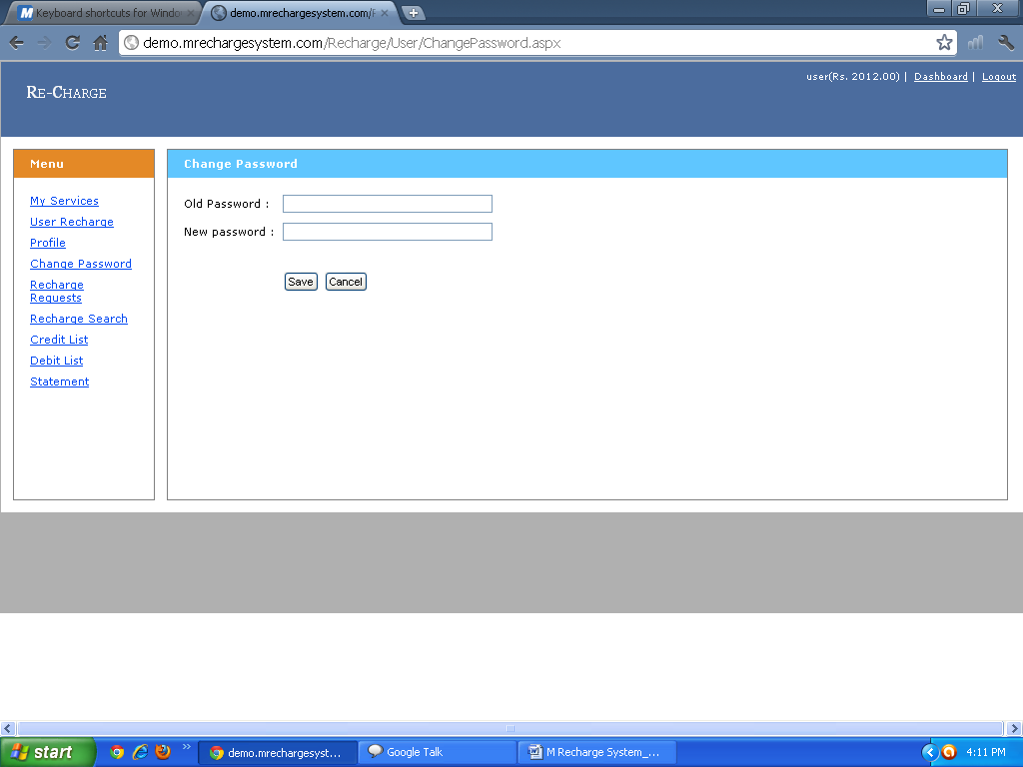

4) Staff Services: Staff Person Can See Service.
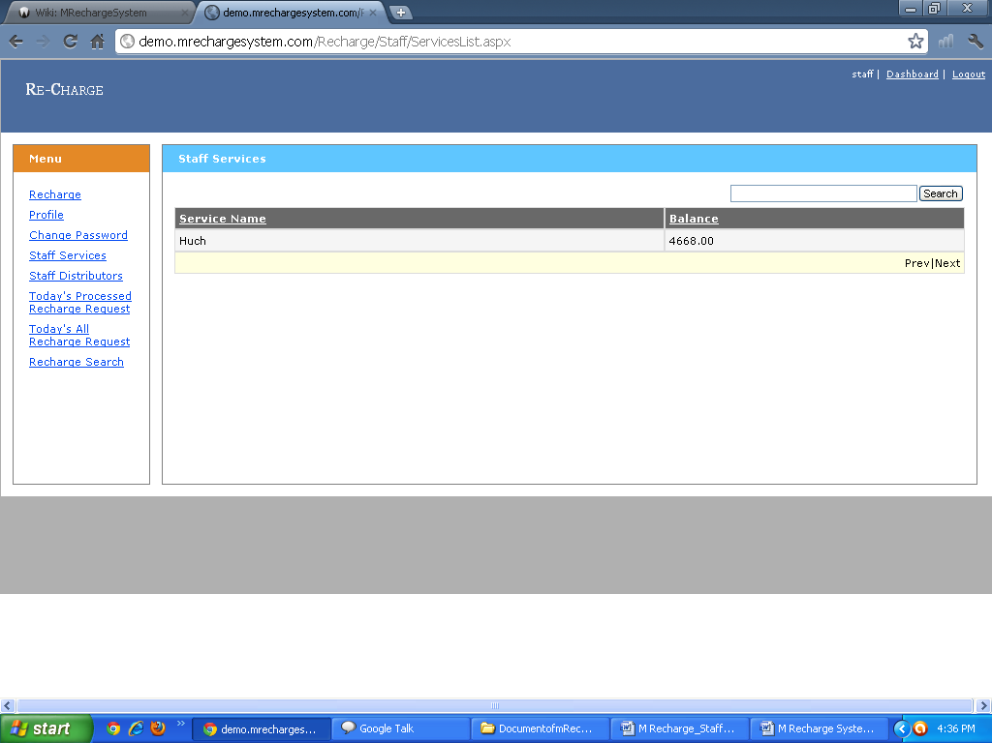
5) Staff Distributors: All Information Regarding Distributor can see.
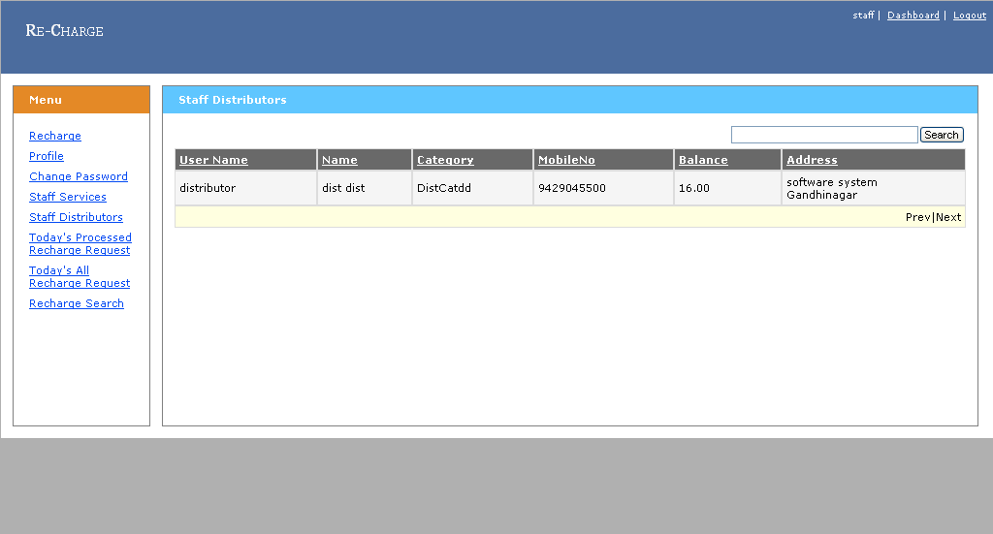

6) Recharge Request: Staff Person can see All the information Regarding Admin, Distributor, Dealer, user and can Request for Recharge.
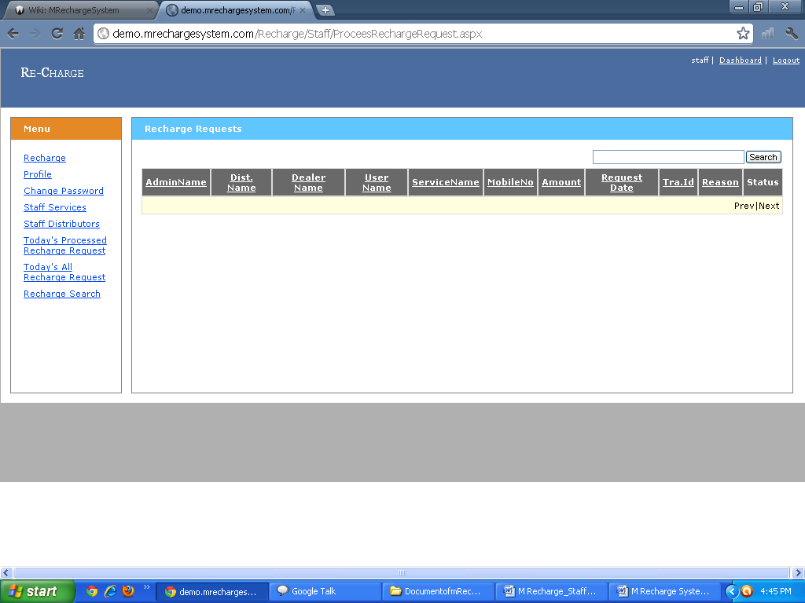 7) Recharge Search: Staff Member can find Particular Admin, Distributor, Dealer, and User Using Advance Search. 